GREEN SOCIETY PUBLIC SCHOOL
Ratnanagar -7, Sauraha, Chitwan
Date: 2082/11/25
Ratnanagar Municipality has scheduled the “BASIC LEVEL EXAMINATION-2082” to be started from 8th of Chaitra, 2082. Therefore, the guardians are kindly requested to prepare and facilitate their children in their studies at home. Moreover, the guardians are duly requested to clear all fees up to the month of Chaitra 2082 by or before 4th of Chaitra, and receive the Examination Entrance Card.
EXAM ROUTINE
Time - 01:30 PM to 03:30 PM
Date | Day | Subject
2082/12/08 | Sunday | C. Maths
2082/12/09 | Monday | g]kfnL
2082/12/10 | Tuesday | C. English
2082/12/11 | Wednesday | HPCA
2082/12/12 | Thursday | C. Science
2082/12/15 | Sunday | ;fdflhs cWoog
2082/12/16 | Monday | HRHG

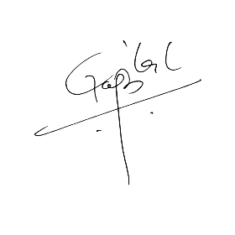
Note:

Head Teacher
GREEN SOCIETY PUBLIC SCHOOL
Ratnanagar -7, Sauraha, Chitwan
Date: 2082/11/25
Ratnanagar Municipality has scheduled the “BASIC LEVEL EXAMINATION-2082” to be started from 8th of Chaitra, 2082. Therefore, the guardians are kindly requested to prepare and facilitate their children in their studies at home. Moreover, the guardians are duly requested to clear all fees up to the month of Chaitra 2082 by or before 4th of Chaitra, and receive the Examination Entrance Card.
EXAM ROUTINE
Time - 01:30 PM to 03:30 PM
Date | Day | Subject
2082/12/08 | Sunday | C. Maths
2082/12/09 | Monday | g]kfnL
2082/12/10 | Tuesday | C. English
2082/12/11 | Wednesday | HPCA
2082/12/12 | Thursday | C. Science
2082/12/15 | Sunday | ;fdflhs cWoog
2082/12/16 | Monday | HRHG


Note:

Head Teacher

